**Business Problem**

Effective inventory and sales management are critical for optimizing profitability in the retail and wholesale industry. Companies need to ensure that they are not incurring losses due to inefficient pricing, poor inventory turnover, or vendor dependency. The goal of this analysis is to:

* Identify underperforming brands that require promotional or pricing adjustments.
* Determine top vendors contributing to sales and gross profit.
* Analyze the impact of bulk purchasing on unit costs. Assess inventory turnover to reduce holding costs and improve efficiency.
* Investigate the profitability variance between high-performing and low-performing vendors.

**Exploratory Data Analysis Insights  
Summary Statistics**

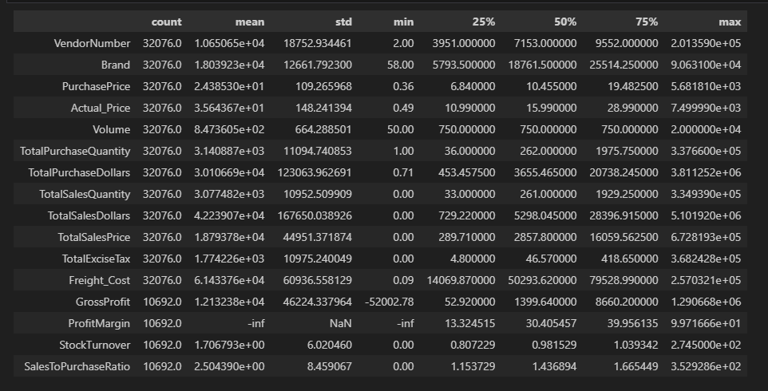

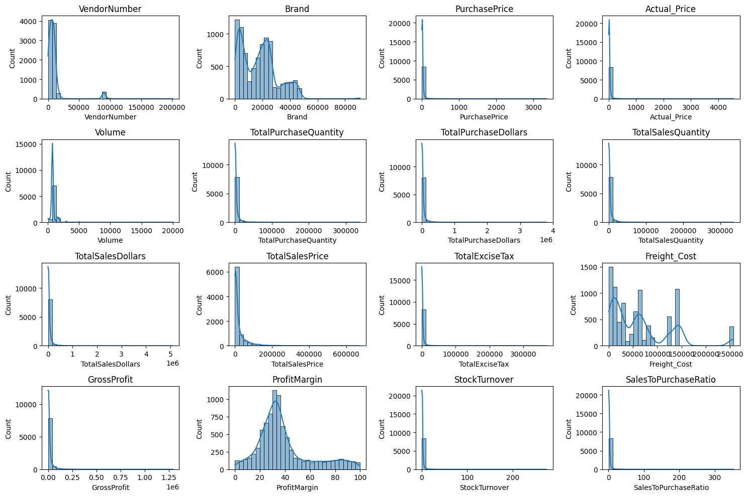

**Negative & Zero**

**Values Gross** Profit: A minimum of -52,002.78 shows some products are sold at a loss due to high costs or heavy discounts. This signals pricing or procurement inefficiencies.

**Profit Margin**: The -∞ margin occurs when revenue is zero or below costs, meaning items are sold at a loss or not sold at all.

**Sales Quantity & Dollars**: Minimum 0 means some items were bought but never sold, pointing to overstocking, poor demand, or obsolete inventory.

**Outliers by High Standard Deviations**

**Purchase & Actual Prices**: Max values (5,681.81 & 7,499.99) far exceed averages (24.39 & 35.64), suggesting premium or luxury items that skew overall averages.

**Freight Cost:** Ranges from 0.09 to 257,032.07, showing huge variation due to bulk orders, international shipments, or inefficiencies in logistics.

**Stock Turnover:** Varies from 0 to 274.5, meaning some products never sell while others sell rapidly. Turnover above 1 shows sales are met from older stock.

**Data Filtering**

To enhance the reliability of the insights, we removed inconsistent data points where:

* Gross Profitis ≤ 0 (to exclude transactions leading to losses).
* Profit Margins ≤ 0 (to ensure analysis focuses on profitable transactions).
* Total Sales Quantity = 0 (to eliminate inventory that was never sold).

**Correlation Insight**

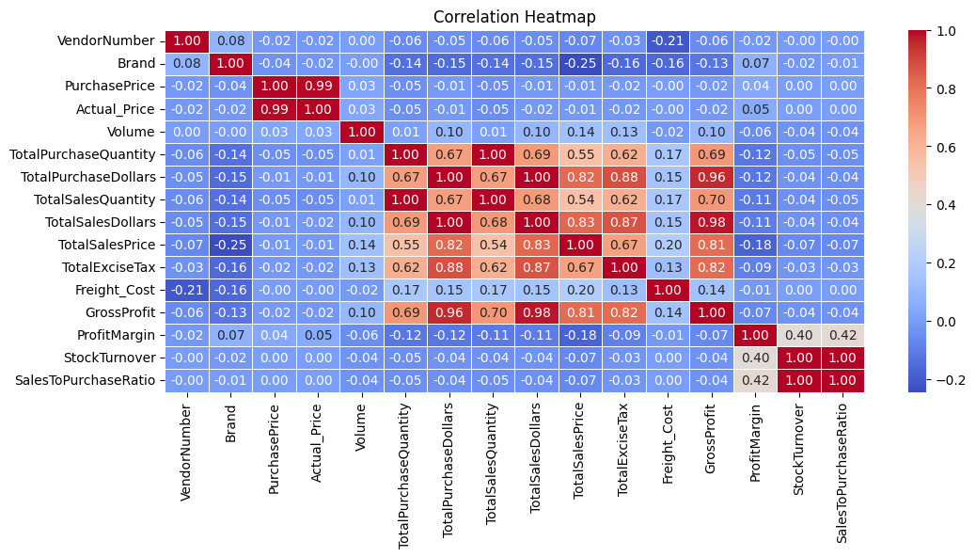

**Purchase Price vs. Total Sales Dollars & Gross Profit:** The correlations are very weak (**-0.012** and **-0.016**), showing that purchase price changes have minimal impact on overall revenue or profitability.

**Total Purchase Quantity vs. Total Sales Quantity:** A nearly perfect correlation (**0.999**) indicates highly efficient inventory usage, with most purchased stock being successfully sold.

**Profit Margin vs. Total Sales Price:** The negative correlation (**-0.179**) suggests that as sales prices rise, margins tend to shrink, likely due to competitive pressures or increased costs.

**Stock Turnover vs. Gross Profit & Profit Margin:** Weak negative correlations (**-0.038** and **-0.055**) imply that faster stock movement does not necessarily lead to higher profitability.

**Research Questions & Key Findings**

**1.Brands for Promotional or Pricing Adjustments**

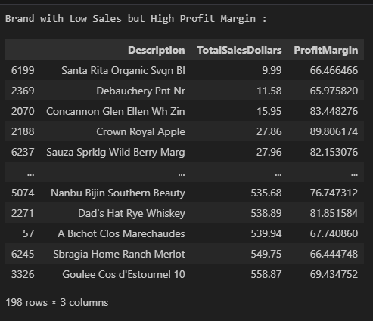

198 Brands exhibit lower sales but higher profit margins, which cloud benefit from targeted marketing ,promotions or price optimizations to increase volume without compromising profitability.

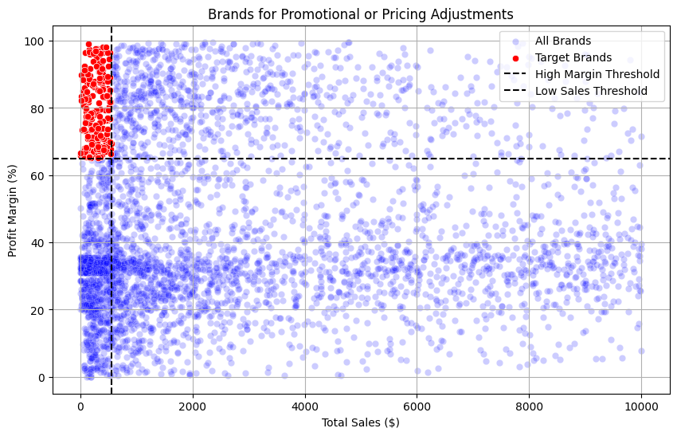

**2.Top Vendors by Sales & Purchase Contribution**

The top 10 vendor contribute 65.69% of total purchases, while the remaining vendor contribute only 34.31% . This over-reliance on a few vendors may introduce risk such as supply chain distribution, indicating a need for diversification.

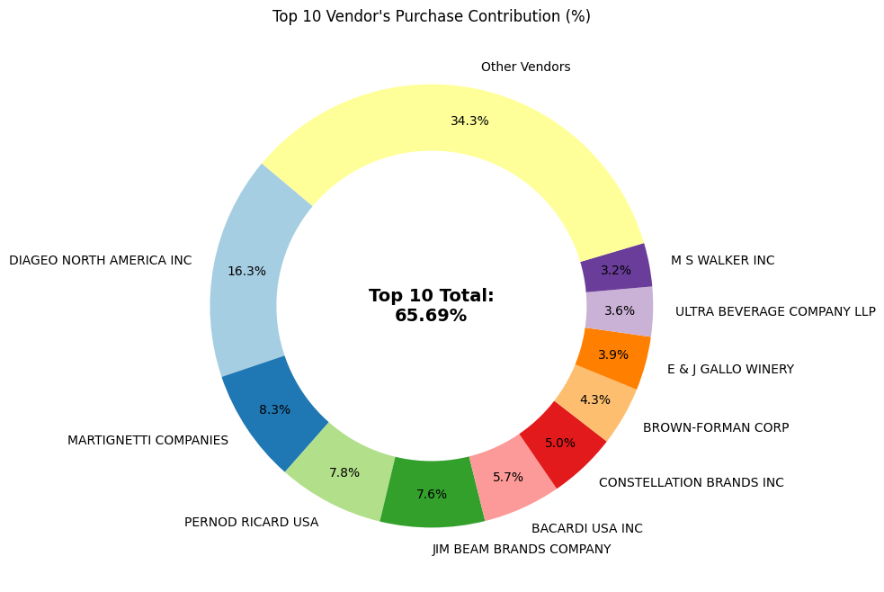

**3.Impect of Bulk Purchasing on Cost Savings**

Vendors buying in large quantities receive a 72% lower unit cost ($10.78 per unit vs. higher unit costs in smaller orders).

Bulk pricing strategies encourage large orders, increasing total sales while maintaining profitability.

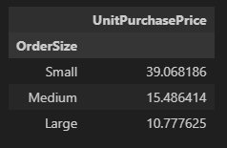

**4. Vendors and Brands with Strongest Sales Performance**

**Top Vendors by Sales**: Diageo North America Inc. dominates vendor sales with nearly $68M, far ahead of the next vendor, Martignetti Companies at $39M. This highlights Diageo’s strong market presence and brand portfolio strength.

**Top Brands by Sales**: Jack Daniels No 7 Black leads with about $7.96M, followed closely by Tito’s Handmade Vodka ($7.40M) and Grey Goose Vodka ($7.21M). This shows that premium whiskey and vodka brands are key sales drivers.

**Market Concentration**: While sales are spread across multiple vendors and brands, a small group of top performers capture a disproportionately large share of sales. This concentration suggests that focusing on partnerships with leading vendors and promoting top-selling brands could maximize revenue growth.

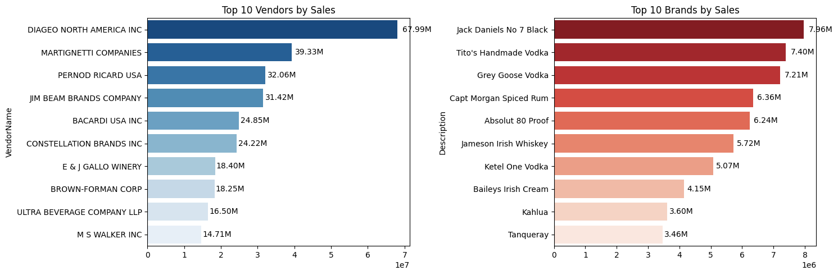

**5. Vendors Contributing the Most to Total Purchase Dollars**

**Dominant Vendor Contribution**: Diageo North America Inc. leads significantly, contributing 16.3% of total purchase dollars and generating the highest sales ($67.99M) and gross profit ($17.89M). This makes it the most influential vendor in terms of both spend and returns.

**Cumulative Impact of Top Vendors**: The top six vendors together account for over 50% of total purchase dollars, indicating that a small group of vendors drive the majority of procurement and sales performance.

**Balanced Profitability Across Vendors**: While vendors like Diageo and Martignetti dominate, others such as Constellation Brands and E & J Gallo Winery also show solid gross profits relative to their purchase contributions, reflecting efficient returns on procurement spend.

